**Retail Analysis Dashboard**

1. Load ‘Retail Sales Analysis’ data set
2. Create a Relational Model as the below snapshot

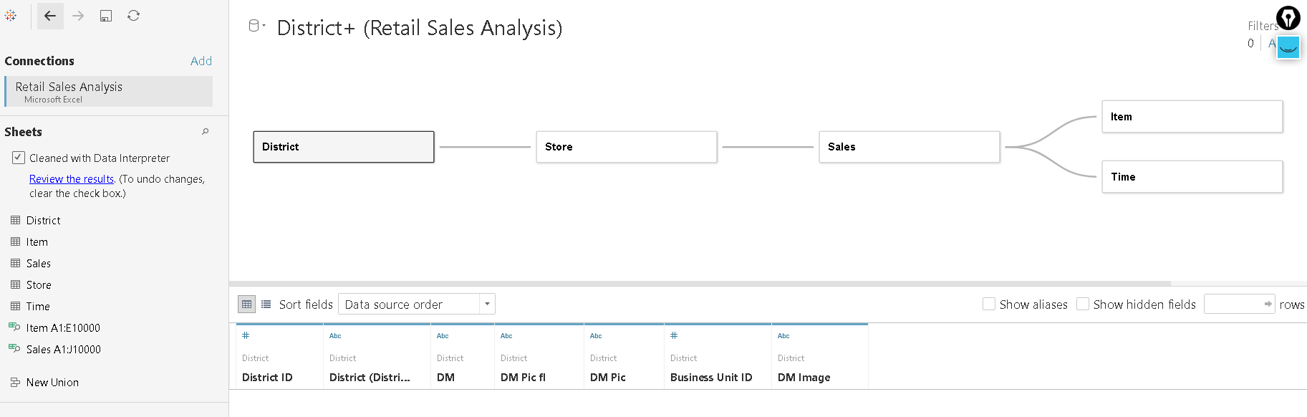

1. Create calculated fields as follows:
2. TotalUnits = [Sum Regular Sales Units]+[Sum Markdown Sales Units]
3. Total Units This Year =

IF [Scenario ID]=1

THEN [TotalUnits]

ELSE 0

END

1. TotalSales = [Sum Regular Sales Dollars]+[Sum Markdown Sales Dollars]
2. TotalSalesLY =

IF [Scenario ID]==2

THEN [TotalSales]

ELSE 0

END

1. Total Units Last Year =

IF [Scenario ID]==2

THEN [TotalUnits]

ELSE 0

END

1. TotalSalesTY =

IF [Scenario ID]==1

THEN [TotalSales]

ELSE 0

END

1. This Year Sales = [TotalSalesTY]
2. Total Sales Var = [TotalSalesTY]-[TotalSalesLY]
3. Total Sales Variance = [Total Sales Var]
4. Total Sales Var % = (IIF([TotalSalesLY]!=0, ([Total Sales Var]/[TotalSalesLY])/100,0))
5. Total Sales Variance % = [Total Sales Var %]
6. Avg $/Unit TY =

IF

[Total Units This Year]!=0

THEN

[TotalSalesTY]/[Total Units This Year]

ELSE 0

END

1. Avg $/Unit LY =

If[Total Units Last Year]!=0

THEN [TotalSalesLY]/[Total Units Last Year]

ELSE 0

END

1. Average Unit Price Last Year = [Avg $/Unit LY]
2. Average Unit Price = [Avg $/Unit TY]
3. Last Year Sales = [TotalSalesLY]
4. Store Count = COUNTD([Location ID])
5. Markdown_Sales_Dollars = SUM([Sum_Markdown_Sales_Dollars])
6. Markdown_Sales_Units = SUM([Sum_Markdown_Sales_Units])
7. Regular_Sales_Dollars = SUM([Sum_Regular_Sales_Dollars])
8. Regular_Sales_Units = SUM([Sum_Regular_Sales_Units])

22) Sales Per Sf FT = SUM([TotalSalesTY])/(COUNTD([Month ID])

*SUM([Selling Area Size]))*12

1. Gross Margin Last Year =

IF [Scenario ID]=2

THEN ([Sum GrossMarginAmount])

END

1. Gross Margin Last Year % = [Gross Margin Last Year]/[TotalSalesLY]
2. Gross Margin This Year =

IF ([Scenario ID])=1

THEN ([Sum GrossMarginAmount])

END

1. Gross Margin This Year % = [Gross Margin This Year]/[TotalSalesTY]
2. Average Selling Area Size = AVERAGE([SellingAreaSize])
3. New Stores =

COUNT(

IF [Store Type]='New Store' THEN [Store Type]

END)

1. Total Stores = COUNT([Store Number Name])
2. Create the following metrics/ Graphs in individual worksheets:

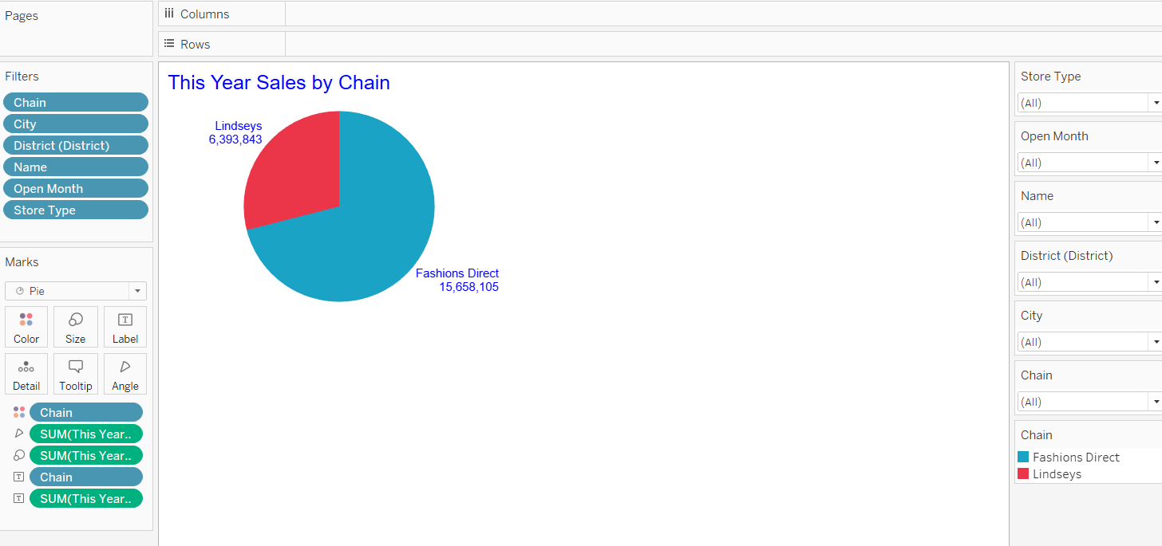

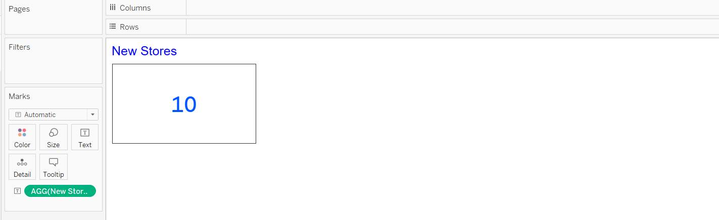

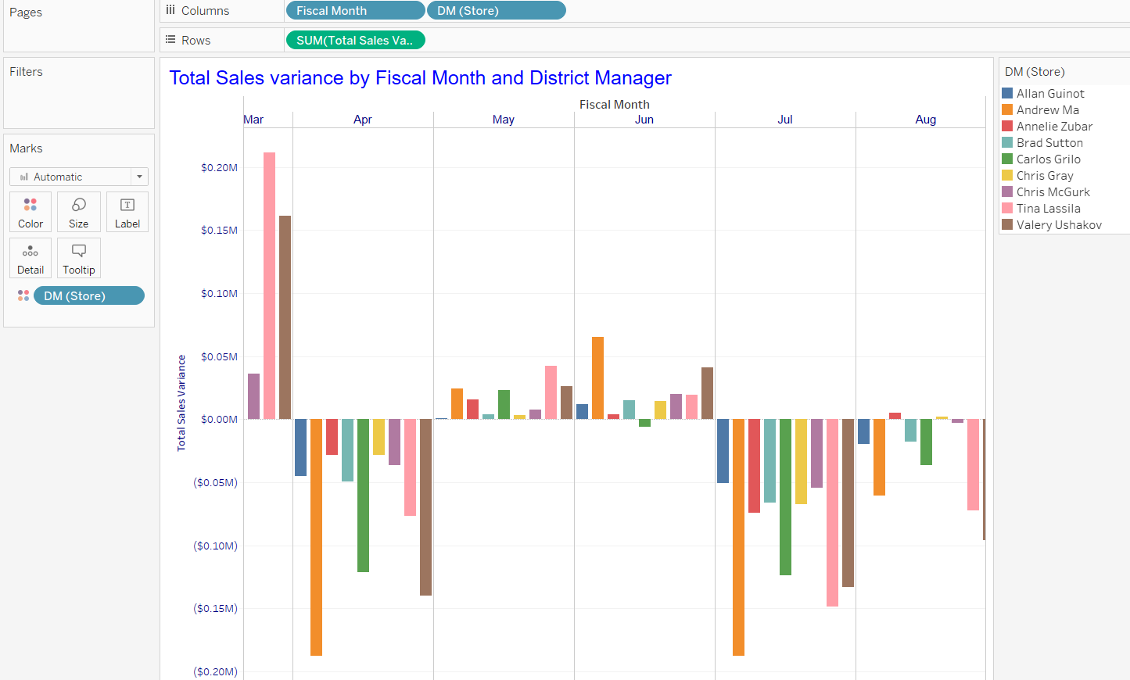

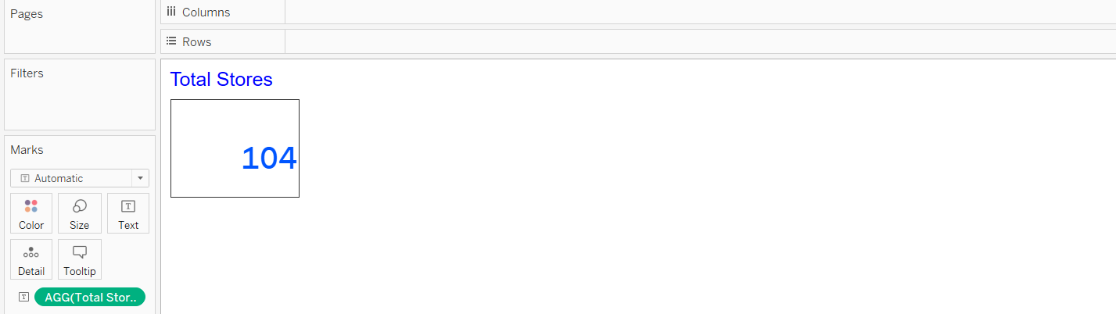

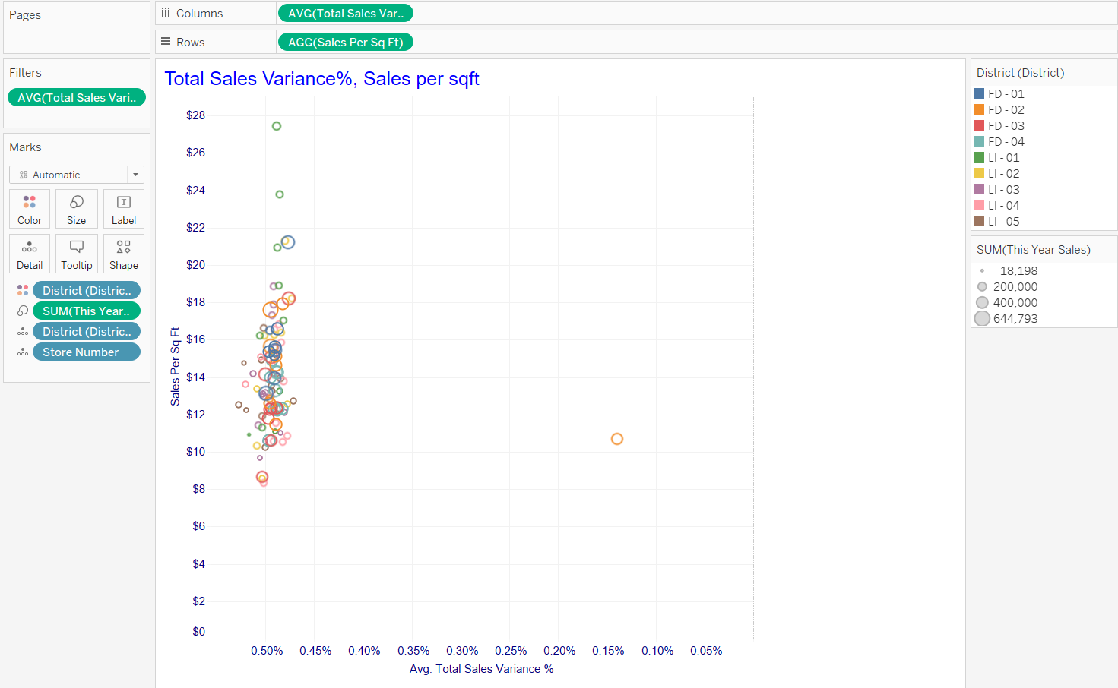

1. Create a dashboard named ‘ Overview ‘. Format the dashboard as the following snapshot

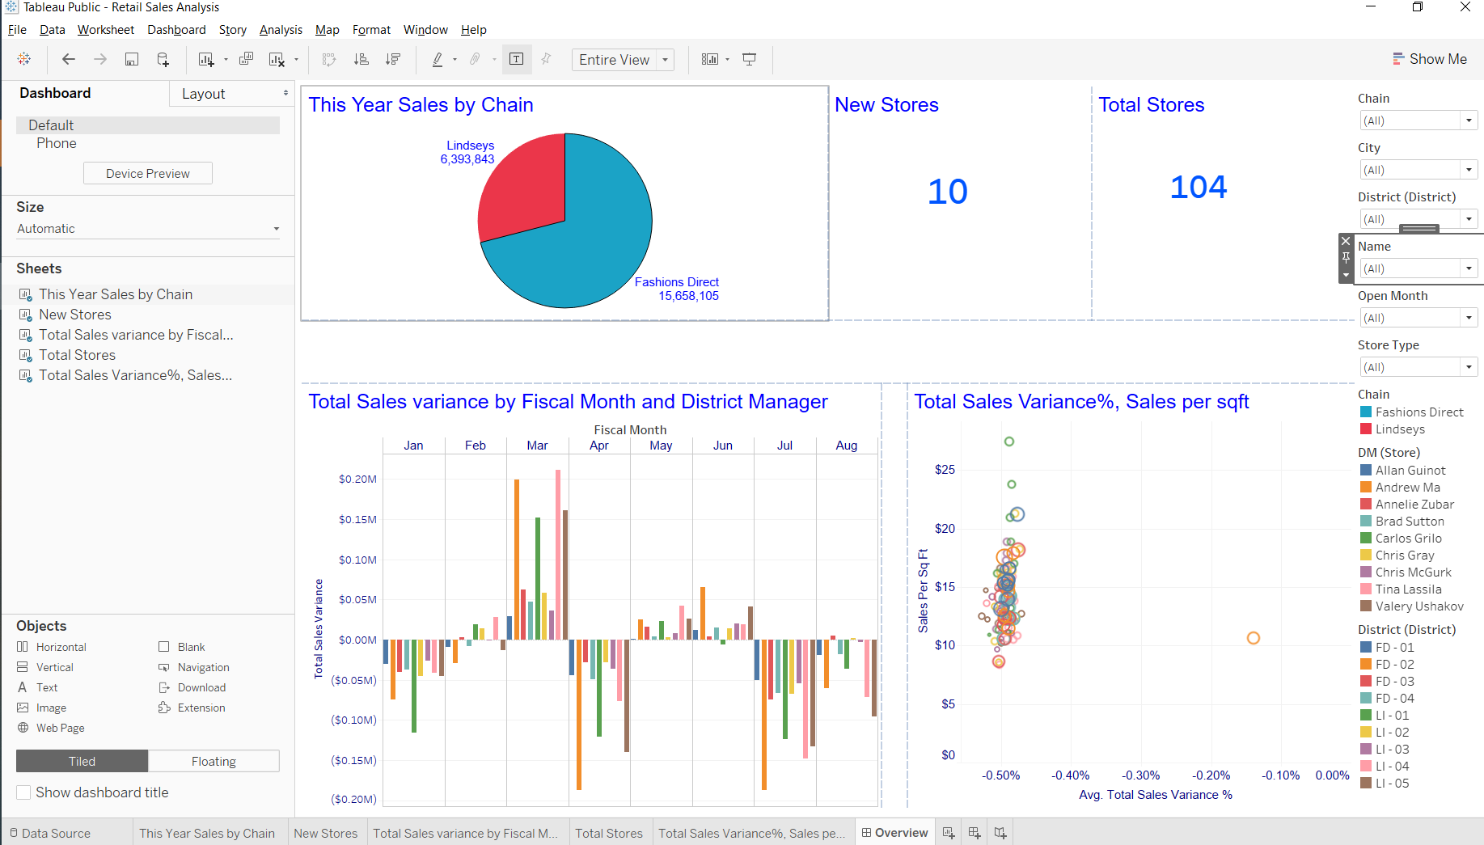

1. Publish the work on Tableau public account and share the link on chat window

**October 28,2021 – Class Exercise**

1. Open ‘Retails Sales Analysis’ workbook and browse the dataset only if you are prompted.
2. Create a new calculated field as follows:

**Open Store Count = COUNT([Open Date])**

1. Create the following graph

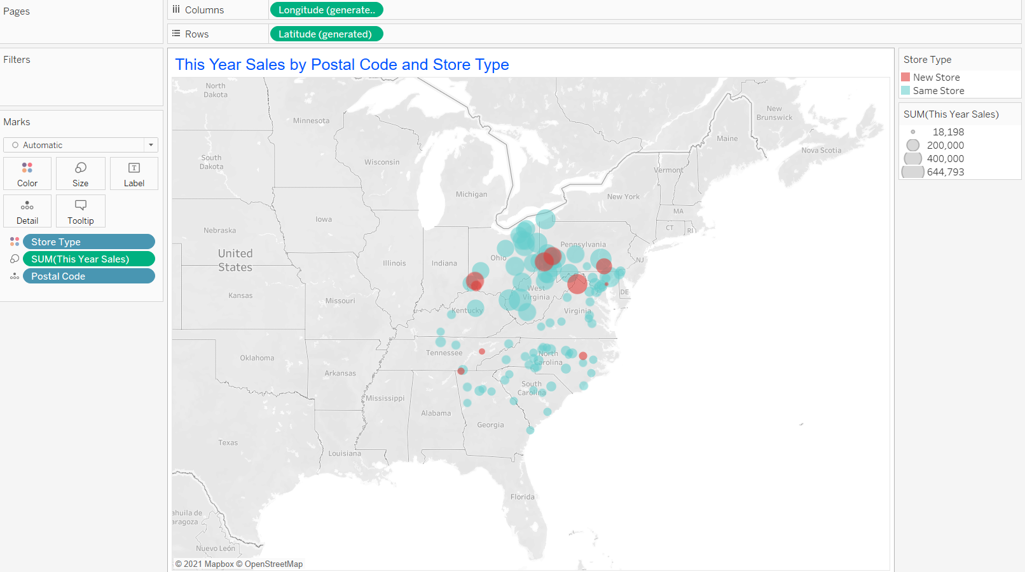

1. Locate the above graph in ‘Overview’ Dashboard. Accordingly, rearrange the graphs in the dashboard

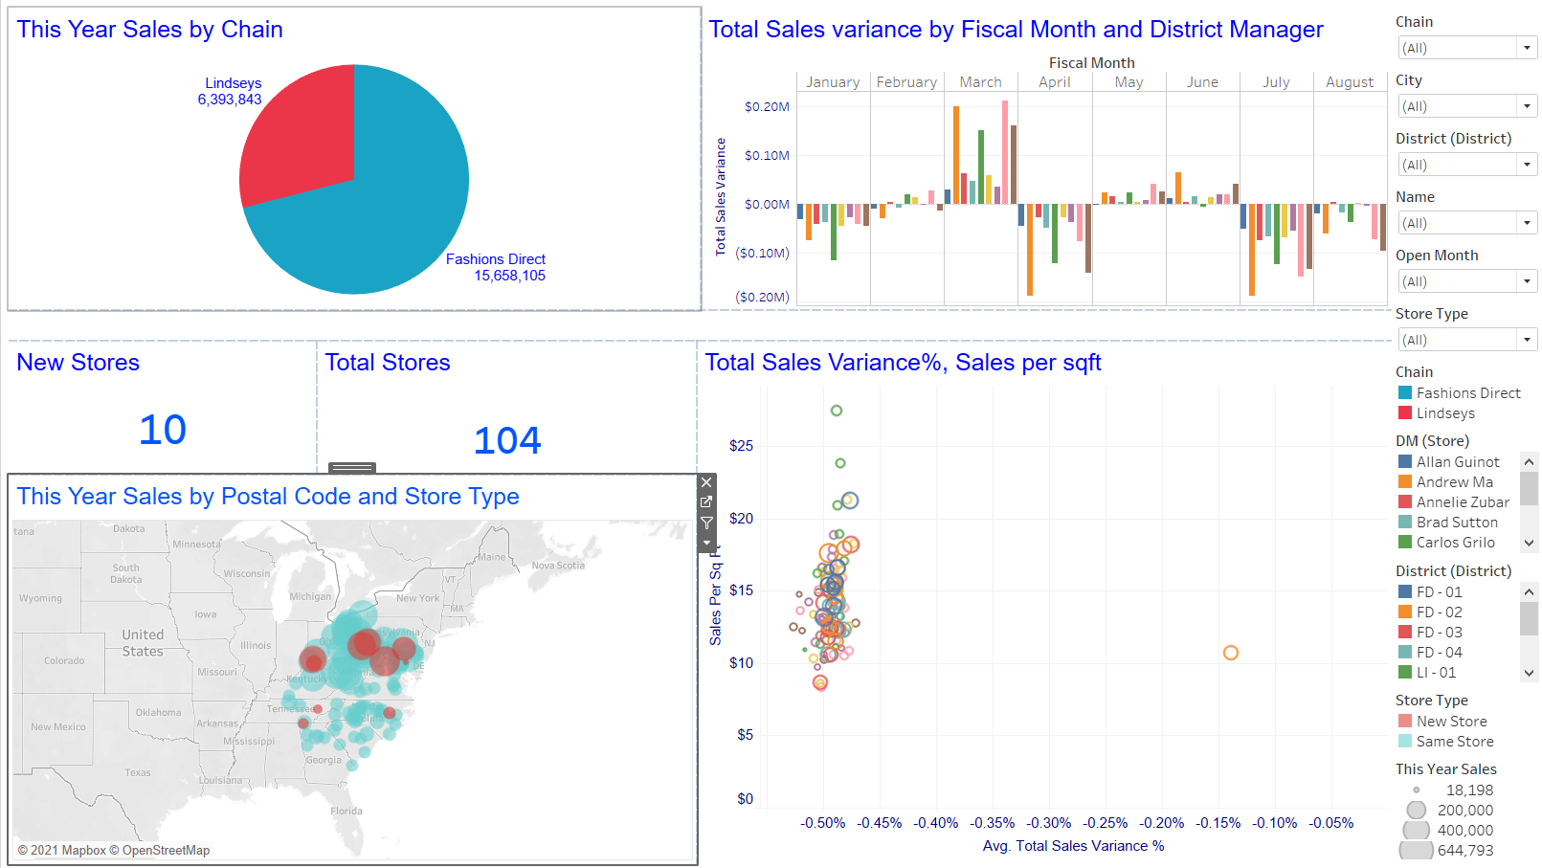

1. Create the following Graphs

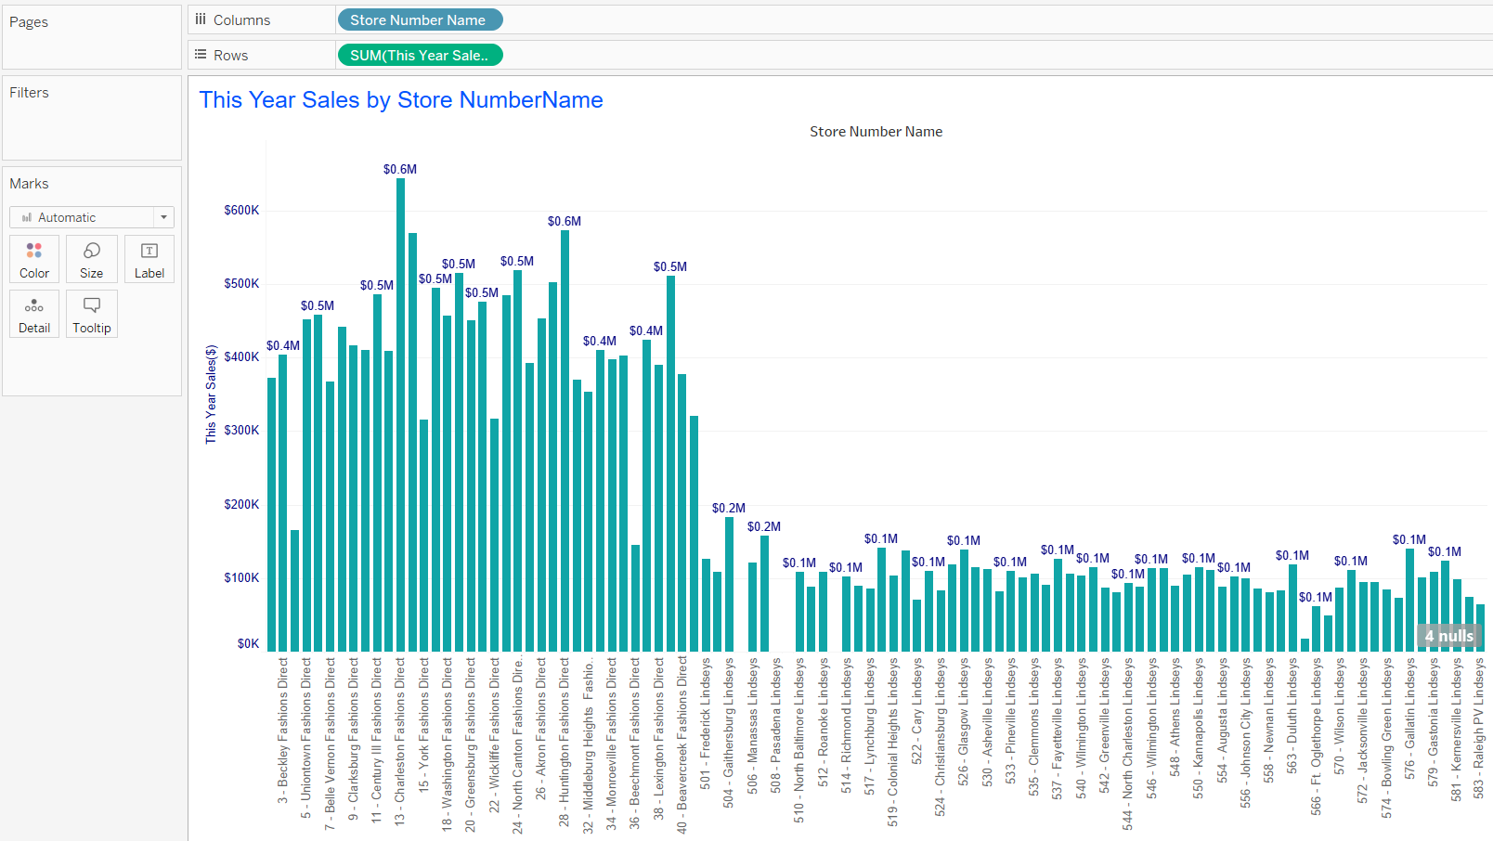

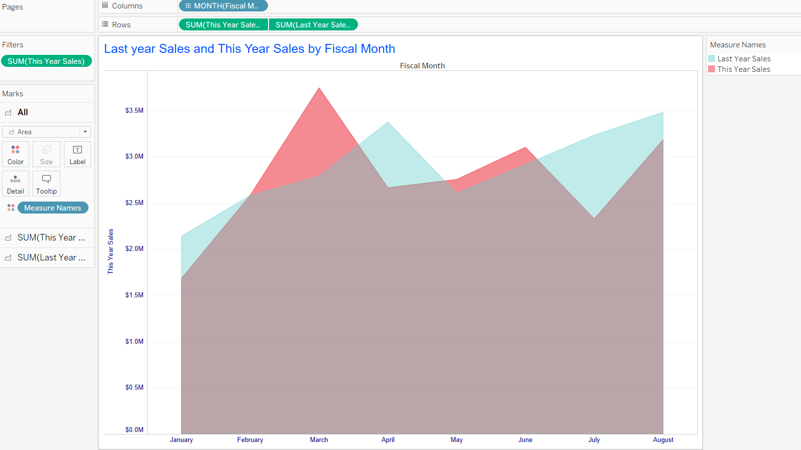

1. Create dashboard named ‘District Monthly Sales’ and locate the graphs

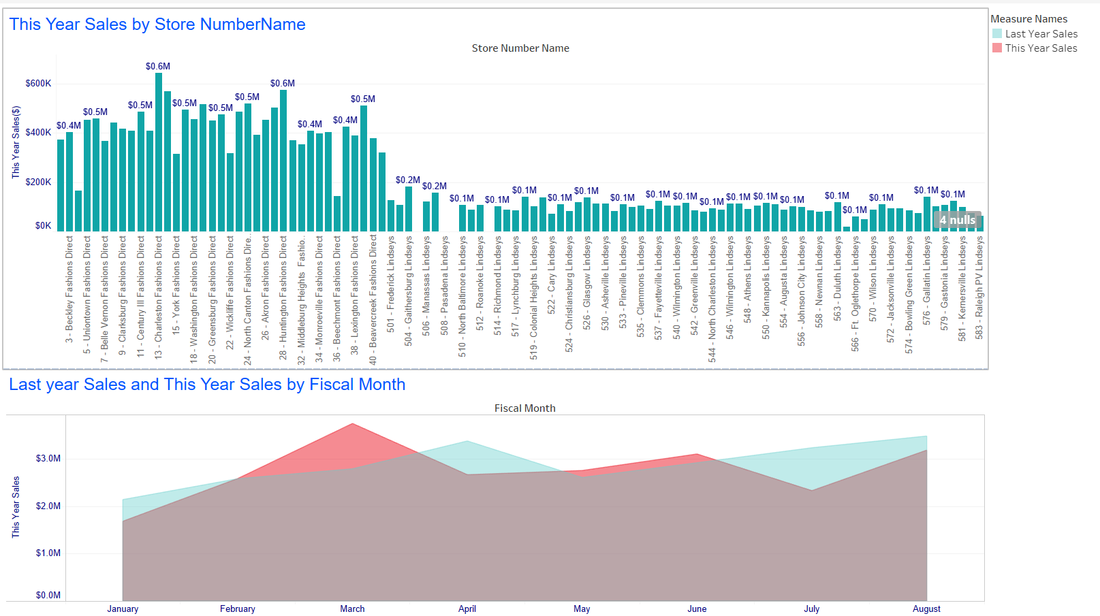

1. Create graphs as follows:

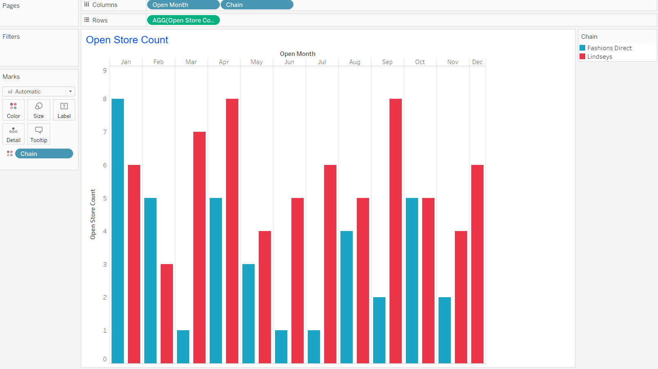

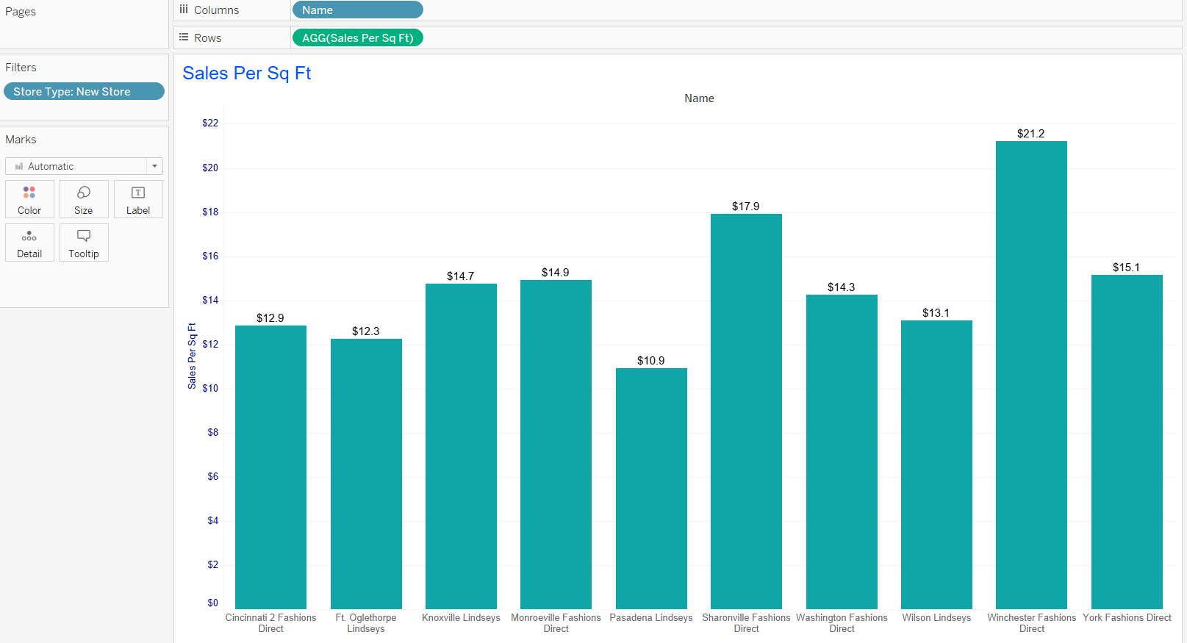

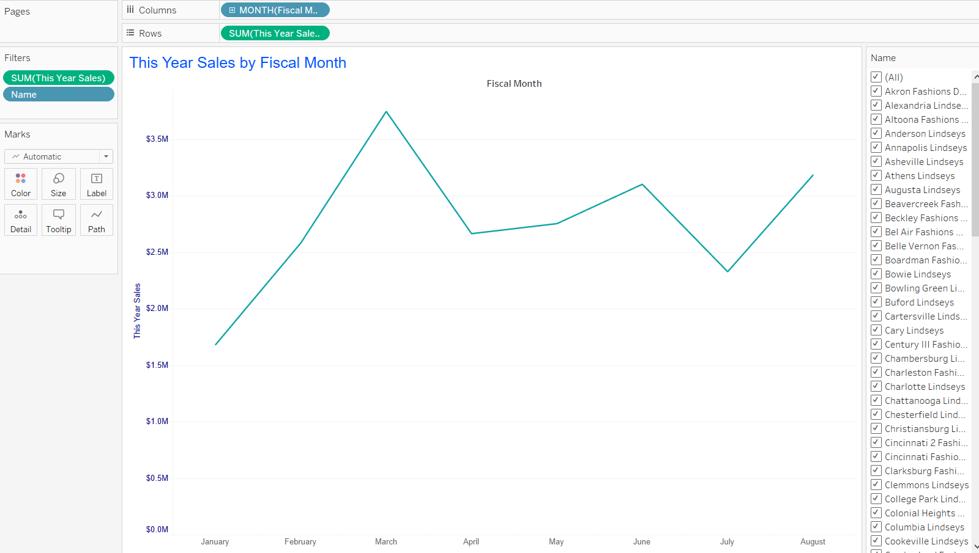

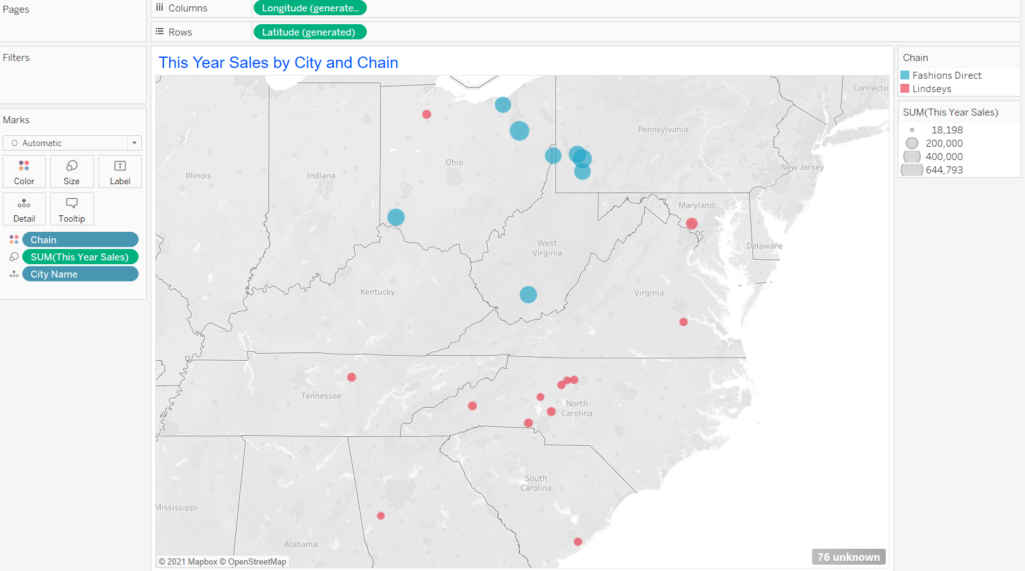

1. Create dashboard named ‘New Store Analysis ‘ and locate the graphs

